Equine Recurrent Uveitis
Information for owners of Knabstrupperhorses about Uveitis and ERU
Content

Introduction 1
What is Uveitis and ERU? 2
What causes Uveitis and ERU? 2
Acute, Chronic and End-stage Uveitis 3
Symptoms 3
Equine Recurrent Uveitis – ERU 4
Treatment, prevention and prognosis 6
Heritability 6
Registration of eye disease in Knabstruppers 7
References 8

Introduction
ERU is one of the longest known eye diseases. ERU was formerly known as ”Moon-blindness”, as it was assumed, the reason for its recurrens was connected to the moon. To this day, ERU is still the most common cause of blindness in horses.

The occurrence of ERU is 2-25 % in USA, 8-10 % in Central Europe and <1% in England (Allbaugh, 2017). The difference world wide of the frequency of ERU is believed to be caused by genetic and enviromental factors. A Canadian study from 2017 showed that 62.5 % of horses afflicted with ERU were Appaloosa horses (Lynne S. Sandmeyer, 2017). This corresponds with an older study from USA in 1995, which showed that Appaloosa horses were 8,3 times more likely to develop ERU (Dwyer AE, 1995). At present there is no research into the prevalence of ERU in Knabstrupper horses, but there is no doubt, that the Knabstrupper with the LP-gene, is overrepresentated in the statistics. Knabstrupperforeningen for Danmark´s Uveitis Committee wishes to map out the occurrence of ERU in the Knabstrupper horse. For this purpose different initiatives have been taken; a database of Knabstruppers with eye diagnoses, questionnaires for Knabstrupper owners, survey forms and information material for veterinarians and support for various research projects.

What is Uveitis and ERU?
To understand ERU it is important to understand Uveitis. It is also important to understand, that Uveitis is not the same as ERU. The definition of Uveitis is an inflammation in the uvea. Uvea consists of 3 different parts, Iris, Corpus ciliare and Choroidea. Together they stand for most of the blood supply of the eyes and is in direct contact with the peripheral blood circulation.
The inflammation is named differently, depending on which part of the eye is most affected. When the inflammation is localized to the iris and corpus ciliare it is named an anterior uveitis. When the inflammation is localized to the choroid and retina it is called a posterior uveitis. When all of the different parts of the uvea are affected it is called a panuveitis. Unfortunately this is the most common.

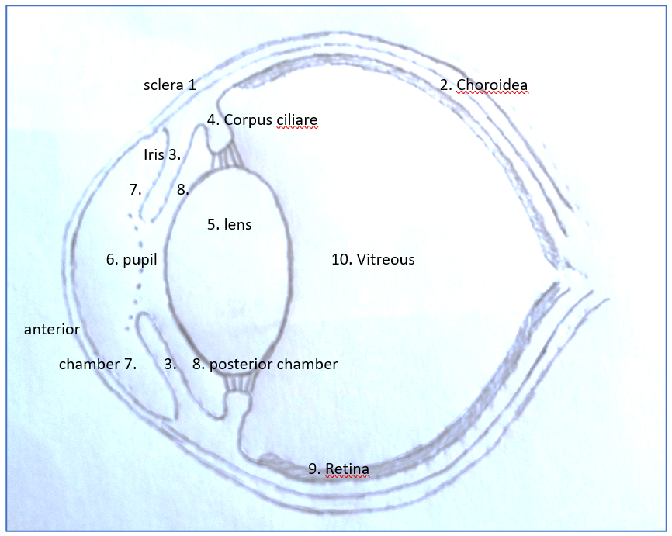

Figur 1 The figures shows a cross section of the eye. Anterior and posterior chamber is divided by the iris.

What causes Uveitis and ERU?
Though Uveitis and ERU has been known for many years, the mechanisms of the disease are not fully understood. Many different causes of inflammation/Uveitis in the eye exist, but they are usually divided into 3 categories. (Gilger B C, 2004);
- Trauma: corneal ulcers, blunt trauma against the eye, corpus alienum (corp al) etc
- Systemic infections: bacteria (for example Rhodococcus equi, Streptococcus, Leptospira), virus (for example Equine influenza, EHV types 1 and 4 (equine herpesvirus), EAV (equine viral arteritis)), parasites (for example Strongylus, Onchocerca, Toxoplasma)
- Immunemediated: the immune system reacts inappropriately to the first acute uveitis. Subsequently the horse will have more bouts of uveitis, without apparent primary cause. The disease is now refered to as ERU.
The disease manifests in several different ways and causes varying degrees of symptoms in the eye, ranging from seemingly painless to great, acute pain. Uveitis will often be devided into the following categories:
- Acute uveitis
- Chronic uveitis
- End-stage uveitis (phthisis bulbi)

Akut, kronisk og end-stage uveitis Acute, chronic and end-stage uveitis
The cause of acute uveitis can be trauma or systemic infections, but occasionally it is not possible to identify the trigger, just as the symptoms can be seen in varying degrees.

Symptoms
Some of the most common symptoms:
- Blepharospasm
- Red, svollen eyesurroundings such as eyelids, conjunctiva
- Tear flow/ epiphora
- Light sensitivity
- Small contracted pupil (miosis)
- Corneal edema (bluish/white coloured (”nonseethrough”) cornea)
- Vessel growing in cornea, from limbus of the eye towards the middle (corneal vascularization).
- Hypopyon (accumulation of inflammatory cells/pus in anterior chamber), hyphema (accumulation of red blood cells/bleeding in anterior chamber).
The pressure in the eye is low in connection with Uveitis. A constant amount of chamberfluid is continuously produced in, and transported away from the eye. This keeps the pressure in the eye at a constant level. The constant pressure is important for the health of the eye. If the drainage system of the eye is blocked, due to all the inflammatory cells associated with uveitis the pressure rises and the horse develops glaucoma. Glaucoma ends in blindness, as the high pressure in the eye destroys the optic nerve and retina. The most common cause of glaucoma is uveitis. Another complication of Uveitis is retinal detachment.
If Uveitis becomes a chronic condition, further symptoms are seen in the eyes. Often adherences between iris and lens are seen, this may be seen elsewhere in the eye too. The adherence causes the pupil which normally opens and closes according to how strong the light is in the surroundings (small and contracted in strong light, open in dim light), to become inflexible. This obviously impaires the horses vision.
In cases with chronic uveitis iris tend to change in colour. Often the iris gets darker and it is not uncommon the iris has lighter areas, spots of depigmentation in chronic stages. Cataract is another common complication to chronic uveitis.
If the inflammation due to uveitis in the eye are not stopped or if treatment fails, the eye will become blind. The eye ”dies”. It shrinks and becomes a small, softish non seeing eye - Phthisis bulbi. Many of the formerly described symptoms are seen. This is called ”End Stage Uveitis”.

Equine Recurrent Uveitis – ERU
ERU is defined by repeated bouts of Uveitis. The interval between the episodes can vary considerably ranging from weeks to years. Following each episode, more chronic damage will be generated, leading to increased risk of blindness. In 90% of cases, the condition will be bilateral, affecting both eyes (Sandmeyer L S, 2017). The condition is often noticed only when the horse is around 10-12 years old, but at this time the condition will often have been present for so long, great chronic damage has already been generated at the time of the diagnosis.
With horses developing ERU, the cause of the primary Uveitis is often unknown, just as the reason it becomes a recurrent problem is largely unknown. It is generally accepted though, that the immune system of the individual horse plays a large role in the development of the condition (L, 2013)
Attacks of Uveitis may vary greatly. In cases of classic ERU, severe inflammation is seen. There is no doubt, that the horse is very affected in the eye and is in great pain. The attacks return with varying intervals alternating with quiet calm periods. The symptoms are gradually replaced by chronic changes

Horses with LP-gene and PATN-gene (like Knabstruppers) are most often affected by a type of ERU called Insidious ERU. The name ”Insidious ERU” accurately describes this form of ERU. Insidious ERU is characterized by a low grade inflammation of the eye often without obvious symptoms. But slow and gradual degradation of the inner structures in the eye follows (Gilger B C, 2004) (L, 2013).
It can be difficult to detect this gradual degradation of the eye in the early stages, as the symptoms are often non existent or at the most consists of increased tearflow or slight redness around the eye. It is not unusual to see severely impaired vision in the horse, the first time it is examined by a veterinarian.
In most cases, both eyes are affected, but often with different timelines. One eye is affected by symptoms before the other eye. Years can pass before the other eye is affected.
The fact, that symptoms in the eyes in many cases, are so minimal and indistinct is problematic, as the horses owner often will not notice it, before the disease is quite advanced. One reason could be, that our horses have an unusually good temperament. Another significant reason could be, that all homozygote whiteborn (LP/LP – horses) are born without night vision. This means they are used to have impaired vision in the dark hours, therefore the problem is not so big when the vision slowly degenerates during the light hours. If the horse is in his usual safe home environment, where he knows his stable and paddock, he knows the way to water and feed. The horse can handle himself in his everyday life, until the vision is extremely bad. This makes it difficult for the horse owner to detect, that anything is amiss.
When the vision is impaired to the degree that the horse is almost blind, he will have trouble finding his food, if you move it in the field. The risk of him running through the fence is increased. In windy conditions the horse will show greater stress. When the vision is impaired, the horse will sharpen its hearing, and it becomes agitated by the increased noise. Horses are flight animals and herd animals too. A stressed horse with impaired vision, can be dangerous to handle and can cause serious accidents if loose in traffic. It can also cause harm to itself and its handlers in such situations.
When the vision disappears completely, the horse can no longer read the other horses gestures. This often increases the problems. You may see the rest of the herd react aggressively and try to chase the blind horse away.
Treatment, prevention and prognosis
To achieve the best possible prognosis it is of great importance the disease is diagnosed as early as possible, and that treatment is started quickly and aggressively in cooperation with the veterinarian. In some cases it may be necessary to consult a veterinary ophthalmologist (veterinarian with special education/competence in eye diseases). At this time it is not possible to cure a horse with ERU. But several known treatments reduce symptoms and duration of the attacks, and therefor will postpone the secondary changes which are leading to “The end stage Uveitis”. Unfortunately, this disease does not always respond optimally to known treatments. This means the effectiveness of treatment and therefore the prognosis varies from individual to individual. Generally, it has to be said, the long term prognosis is bad. Often the horse goes blind due to the chronical changes. Due to their good temperament, many Knabstruppers do well in familiar surroundings despite blindness, while other horses develop behavioral problems, ultimately leading to a decision to put them down.
To some extent, ERU can be prevented by eliminating the known triggers of ERU attacks. It is wise to:
- Ensure optimal worm/parasite treatment.
- Ensure good hoof and tooth care.
- Ensure optimal vaccination procedure.
- Reduce insect problems.
- Control of mice and rats
- Protect the horse against eye injuries in the stable (no hay net, sharp hooks or handles on buckets)
- Reduce exposure to sun light in the summer (fly mask with sun filter, stabling during sun intensive hours)
- Administer good feed an keep fields without stiff weed stems.

Heritability
There can be no doubt, horses with the LP-gene have greater risk of developing ERU (Dwyer AE, 1995). The Dwyer study in 1995 showed the risk to be 8,3 times higher for horses with the LP-gene compared to horses without the LP-gene. It must be noted, this study was conducted on Appaloosa horses in the USA. Allbaugh shows great differences in the prevalence of ERU in different countries (Allbaugh, 2017). One cannot necessarily draw direct parallels to all countries and to the Knabstrupper, but we have to recognize, that the prevalence of ERU in Knabstruppers is higher than in solid coloured horses.
There is a lot of research in this field at the moment and geneticists have shown a greater risk of developing this form of ERU if the horse is homozygote LP/LP, but even LP/lp are affected. Solid coloured Knabstruppers do not have an increased risk of developing ERU. There are indications some horse families/breeding lines have a significantly greater prevalence of ERU. This is one of the aspects we hope to get some clarification on, through registration of horses with known disease and their descent.
ERU can affect horses of all ages. Unfortunately, it is quite common the diagnosis is made only when the horse is about 10 – 15 years old, because it is often at this age, the disease is so advanced and the symptoms become apparent to the horse owner. In connection to excluding horses with ERU from the breeding program, this is a big problem, as many horses have been active in the breeding program for many years when the diagnosis is made.
At this time, it is uncertain if exclusion of horses with ERU from the breeding program will solve the problem, though. The great variation in the prevalence of ERU across borders suggests a significant environmental factor in the prevalence and development of ERU. Only further study will show, if this is caused by the greater representation of some horse families/breeding lines in certain countries, or if all horses with the LP – gene have the same risk of developing ERU and it depends on environmental factors if the horse develops ERU. Until this is clarified, it is recommended, according to the precautionary principle, to exclude horses with a known ERU diagnosis from breeding, and to submit breeding stock to eye examinations at a regular basis, to establish a diagnosis early in the breeding career.
Registration of eye disease in Knabstruppers
Knabstrupperforeningen for Danmark has decided to register all Knabstruppers with a known eye disease, living as well as deceased, on a voluntary basis. The purpose is to improve knowledge about the prevalence of ERU and other eye diseases in Knabstruppers, to perhaps identify horse families/breeding lines with greater prevalence of ERU and through our register, to contribute to further research in ERU. It is our hope, through this work to produce guidelines for breeding, reducing the risk of ERU in Knabstruppers to normal levels. To carry out this registration, a group called the Uveitis Committee has been set up. Only the committee will process and have knowledge of the contents in the register. Use of the register for research and publication of results will always take place with anonymized data so that indivdual horses cannot be identified. The Uveitis Committee has produced a form for the individual horse owner to fill out and send to:
knabstrupper.eru@gmail.com.
The Uveitis Committee also works to expand knowledge of ERU by producing pamphlets and articles for breeders and horse owners, as well as pamphlets, survey forms and articles for veterinarians. Furthermore work is done to organize collective eye examinations.

References

Allbaugh, R. A. (2017). Equine recurrent uveitis: A review of clinical assessment and management. EQUINE VETERINARY EDUCATION, s. 279-288.
Dwyer AE, C. R. (1995). Association of leptospiral seroreactivity and breed with uveitis and blindness in horses: 372 cases (1986-1993). Journal of the American Veterinary Medical Association , s. 1327-1331.
Gilger B C, M. T. (2004). Equine recurrent uveitis: new methods of mangement. Veterinary Clinics, Equine Practice, s. 417-427.
L, S. (15. 11 2013). The Appaloosa project. Hentet fra https://www.appaloosaproject.co/articles/free-articles/8-equine-recurrent-uveitis.html
Lynne S. Sandmeyer, B. S. (july 2017). Equine recurrent uveitis in western Canadian prairie provinces: A retrospective study (2002–2015). The Canadian Veterinary Journal, s. 717-722.
Sandmeyer L S, B. B. (2017). Equine recurrent uveitis in western canadian prairie provinces: A retrospective study (2002-2015). Canadian veterinary journal , s. 717-722.

Postscript

Since the article was written, more knowledge has been published in the field. Two exciting articles have been published.

H Rockwell 1, M Mack 1, T Famula 2, L Sandmeyer 3, B Bauer 3, A Dwyer 4, M Lassaline 5, S Beeson 6, S Archer 7, M McCue 6, R R Bellone 1 (2020) Genetic investigation of equine recurrent uveitis in Appaloosa horses Animal Genetics 2020 Feb;51(1):111-116

The first article investigate if some DNA markers are directly linked to the occurrence of ERU. The study concludes that the presence of the LP gene underpins an increased risk of developing ERU and that the presence of PATN1 presents an added risk. The functional significance of LP and PATN1 requires further research in the field. Genetic investigation of equine recurrent uveitis in Appaloosa horses - PubMed (nih.gov)
Lynne S. Sandmeyer1 | Nicole B. Kingsley2 | Cheryl Walder3 | Sheila Archer4 | Marina L. Leis1 | Rebecca R. Bellone5 | Bianca S. Bauer1(2020). Risk factors for equine recurrent uveitis in a population of Appaloosa horses in western Canada. Veterinary Ophthalmology. 2020 May;23(3):515-525
The second article is a study on Canadian Appaloosa horses. Age, coat pattern, and genetics are major risk factors for the diagnosis and classification of ERU in the Appaloosa. Risk factors for equine recurrent uveitis in a population of Appaloosa horses in western Canada - PubMed (nih.gov)

